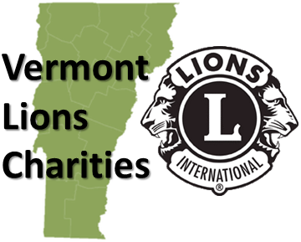
RECIPIENT NAME
STREET ADDRESS
CITY, VT ZIP CODE
Dear Business Owner and Community Member,
Annually Lions Clubs of Vermont have joined together to raise funds for those areas of the state that aren't fortunate enough to have the direct support of their own Lions club. We call it the CAMPAIGN FOR SIGHT. These funds, combined with grants obtained by VLC enable us to help hundreds of Vermonters obtain eyeglasses each year. In 2018 we have already received 165 calls. Vermont Lions Charities has already assisted 43 individuals to receive glasses, and we are still working with another 84. It’s not even April, but this is not unusual; it’s like this every year.
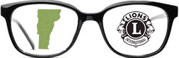
Uncorrected eyesight is a significant barrier to employment. State programs like Medicaid will fund an eye exam, but fail to fund the purchase of eyeglasses. Vermont Lions Charities assists those individuals in need of eyeglasses that have exhausted all other means of financing their own glasses. The CAMPAIGN FOR SIGHT will ensure that program continues to reach Vermonters in need.
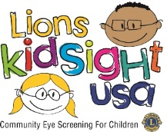
Vermont Lions Charities also sponsors KidSight a program designed to protect the vision of Vermont’s children. VLC purchased four Spot Vision screening cameras which are shared between the Lions Clubs. KidSight builds on our proud history of saving sight and our belief that all children deserve to see the world clearly. Lions in Vermont this year have screened more than 22,000 kids, that’s more than a quarter of Vermont’s K-12 population.
The Shared Vision Fund of Vermont Lions Charities and XXXX Lions club appreciate your support of the CAMPAIGN FOR SIGHT. Your donation will be restricted for use only on Shared Vision Fund (Sight) projects.
Vermont Lions Charities is a 501(c)3 non-profit organization. Contributions can be mailed to the XXXX Lions club at ADDRESS or directly to VLC at: Vermont Lions Charities c/o Lion Woody Stoddard, 163 Whitney Road, Springfield, VT 05159
Sincerely,
Lion XXXXXXXXXXXXXX

501(c)3 Tax ID # 0052427
www.vermontlions.org

